Xray progress 03-01-2026
Test Parameter
Test Parameters are variables defined in a Test that allow the same test to be reused with different data.
Purpose
- Avoid creating duplicate tests
- Support data-driven testing
- Improve test coverage with less maintenance
Example
Test: Verify login functionality
Parameter | Description
username | Login user name
password | Login password
role | User role
Test Steps (using parameters)
1. Enter username: ${username}
2. Enter password: ${password}
3. Click Login
4. Verify dashboard for ${role}
At this stage, parameters are defined, not executed.

Parameter Execution (Parameter Values)
Parameter Execution is when you assign values to the test parameters during execution (inside a Test Execution issue).
Purpose
- Execute the same test multiple times
- Each execution uses different parameter values
- Results are stored per data set

Example – Parameter Values in Test Execution
username | password | role
admin1 | pass123 | Admin
user1 | user@123 | User
guest1 | guest@123 | Guest
Xray will execute the same test 3 times, once for each row.

Key Difference (Quick Comparison)
Aspect | Test Parameter | Parameter Execution
Defined where | Test issue | Test Execution
What it is | Variable placeholders | Actual data values
Purpose | Reusability | Multiple executions
Example | ${username} | admin1, user1

Test Repository

What is Test Repository?
The Test Repository is a folder-like structure used to organize Test issues inside a project.
Think of it as where tests are stored and managed.
Purpose
- Organize tests logically
- Improve test reusability
- Easy navigation and maintenance
- Supports large test suites

Example Structure
Test Repository
├── Login
│ ├── Valid Login
│ └── Invalid Login
├── Checkout
│ ├── Add to Cart
│ └── Payment
└── Regression
Key Points
- Only Test issues live in Test Repository
- Same test can appear in multiple folders
- Moving a test does not change execution or results
- Purely organizational

Test Environment
What is Test Environment?
A Test Environment defines where or under what conditions a test is executed.
Think of it as execution context.
Purpose
- Track results by environment
- Support multi-environment testing
- Better reporting and traceability
Common Examples
- QA
- UAT
- Production
- Chrome
- Firefox
- Android
Example Execution
Test: Verify Login
Environment | Result
QA | Pass
UAT | Fail
Chrome | Pass
Firefox | Fail

Key Differences (Quick Comparison)
Aspect | Test Repository | Test Environment
Type | Organization structure | Execution attribute
Used for | Grouping tests | Tracking execution context
Defined at | Project level | Project / Global settings
Affects execution | No | Yes
Affects reporting | No | Yes

Test Coverage
What is Test Coverage?
Test Coverage shows how well requirements are tested by linking:
- Stories / Requirements
- ↔ Tests
- ↔ Test Executions
It answers: “Is this requirement tested?”
How Coverage Works
- Link Test → Story / Requirement
- Execute the test
- Xray calculates coverage automatically

Example
Story: User Login Feature
Test | Status
Valid Login Test | Pass
Invalid Login Test | Fail
Coverage Result:
- Coverage: 100% (2/2 tests linked)
- Execution status visible at Story level

Coverage Types
Coverage Type | Meaning
Requirement Coverage | Tests linked to Stories
Execution Coverage | Test execution results
Overall Coverage | Pass / Fail / Not Run
]
Where to See Coverage
- Story → Xray Test Coverage panel
- Test Plan → Coverage Report
- Xray Traceability Reports

Defect Mapping
What is Defect Mapping?
Defect Mapping is linking Bugs/Defects to:
- Tests
- Test Executions
- Test Runs
It answers: “Which test found this defect?”

How Defect Mapping Works
- Test execution fails
- Create or link a Bug
- Link Bug to:
  - Test Execution
  - Specific Test Run (recommended)

Example
Test: Invalid Login
Execution | Environment | Result | Defect
Run #12 | QA | Fail | BUG-456
Shows exact test + environment where failure occurred.

Key Differences (Quick Comparison)
Aspect | Test Coverage | Defect Mapping
Purpose | Measure requirement testing | Track defects origin
Linked items | Story ↔ Test | Bug ↔ Test/Test Execution
Focus | Prevention | Detection
Used by | QA, Managers | QA, Dev

Sample image of parameter in test execution:
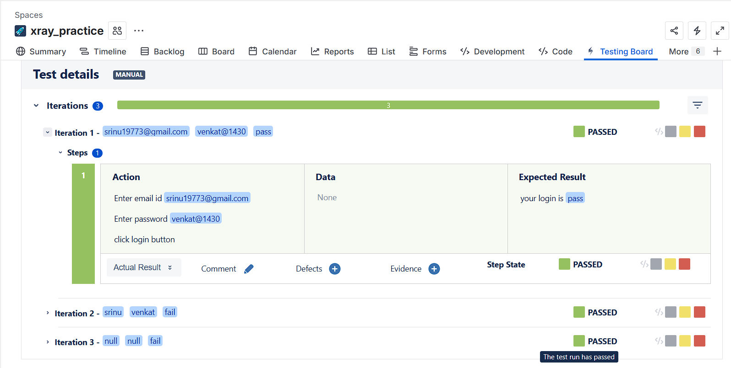

Sample image of Test Coverage
